**ATOC5860 – Application Lab #5**

**Filtering Timeseries**

**Spring 2022**

**Notebook #1 – ATOC5860_applicationlab5**

**ATOC5860_applicationlab5_check_python_convolution.ipynb**

**LEARNING GOAL**

1) Understand what is happening “under the hood” in different python functions that are used to smooth data in the time domain.

Use this notebook to understand the different python functions that can be used to smooth data in the time domain. Compare with a “by hand” convolution function. Look at your data by printing its shape and also values. Understand what the python function is doing, especially how it is treating edge effects.

**Notebook #2 – Filtering Synthetic Data**

**ATOC5860_applicationlab5_synthetic_data_with_filters.ipynb**

**LEARNING GOALS:**

1) Apply both non-recursive and recursive filters to a synthetic dataset

2) Contrast the influence of applying different non-recursive filters including the 1-2-1 filter, 1-1-1 filter, the 1-1-1-1-1 filter, and the Lanczos filter.

3) Investigate the influence of changing the window and cutoff on Lanczos smoothing.

**DATA and UNDERLYING SCIENCE:**

In this notebook, you analyze a timeseries with known properties. You will apply filters of different types and assess their influence on the resulting filtered dataset.

**Questions to guide your analysis of Notebook #2:**

1) Create a red noise timeseries with oscillations. Plot your synthetic data – Look at your data!! Look at the underlying equation. What type of frequencies might you expect to be able to remove with filtering?

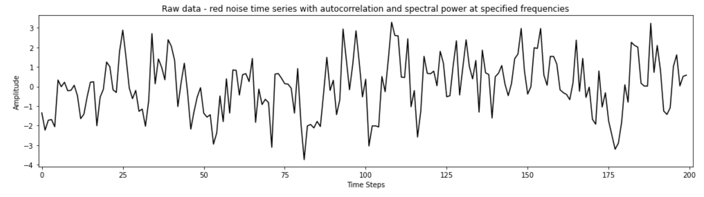

I would expect to remove frequencies that are strongly influenced by np.random terms. When np.random causes a frequency to have a high amplitude, it can bring the amplitude to a value that is anomalously high or anomalously low and vulnerable to smoothing.

2) Apply non-recursive filters in the time domain (i.e., apply a moving average to the original data) to reduce power at high frequencies. Compare the filtered time series with the original data (top plot). Look at the moving window weights (bottom plot). You are using the function “filtfilt” from scipy.signal, which applies both a forward and a backward running average. Try different filter types – What is the influence of the length of the smoothing window or weighted average that is applied (e.g., 1-1-1 filter vs. 1-1-1-1-1 filter)? What is the influence of the amplitude of the smoothing window or the weighted average that is applied (e.g., 1-1-1 filter vs. 1-2-1 filter)? Tinker with different filters and see what the impact is on the filtering that you obtain.

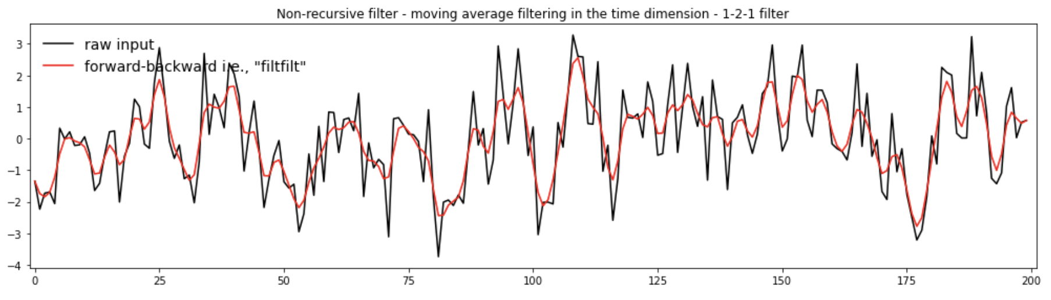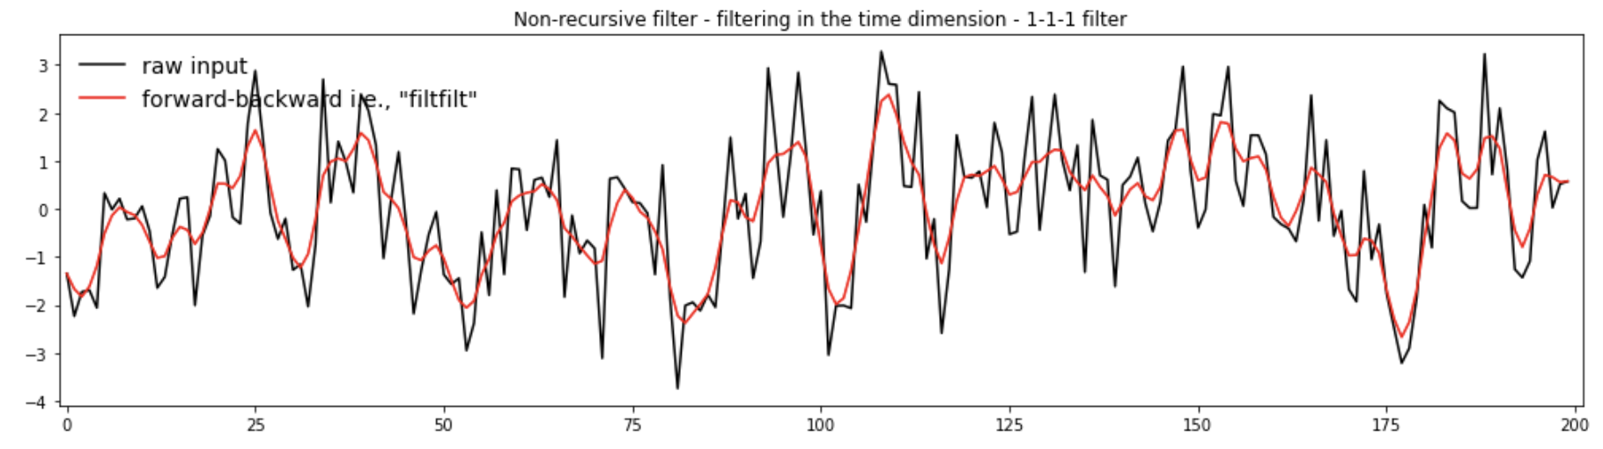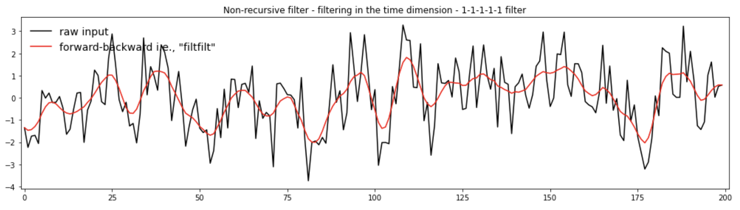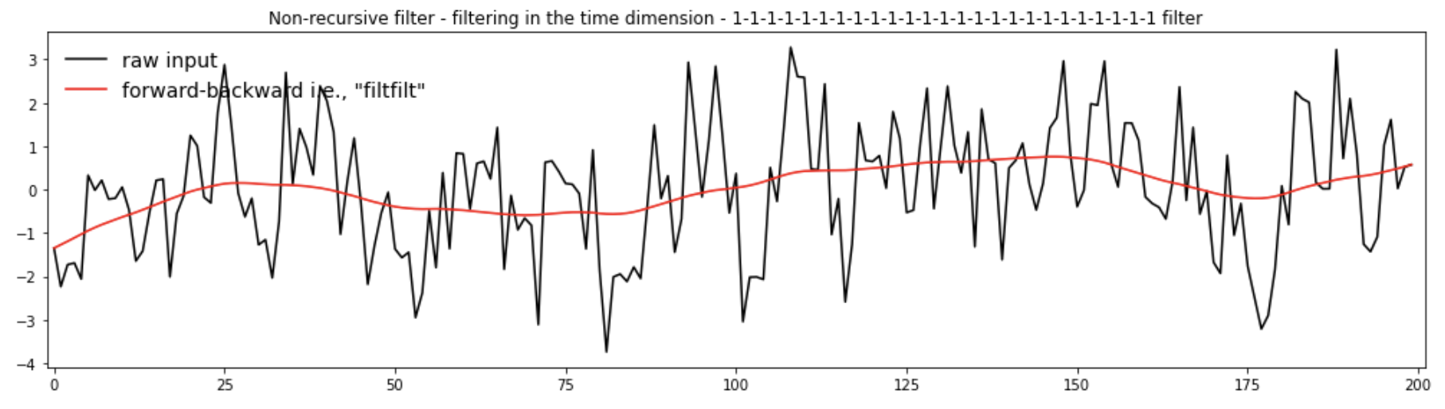

When the length of the filter is increased, the function becomes more smooth. When the amplitude of the smoothing window is increased, the filtered data shifts closer to the raw data.

3) Apply a Lanczos filter to remove high frequency noise (i.e., to smooth the data). What is the influence of increasing/decreasing the window length on the smoothing and the response function (Moving Window Weights) in the Lanczos filter? What is the influence of increasing/decreasing the cutoff on the smoothing and the response function?

Increasing the window size removes more high frequency data. It also causes the range of influence to increase in the response function. However, the primary area range of influence remains more or less the same. Increasing the cutoff value removes less high frequency noise and makes the filtered data less smooth.

4) Apply a Butterworth filter, a recursive filter. Compare the response function (Moving Window Weights) with the non-recursive filters analyzed above.

The butterworth filter is a smoother filter than the non-recursive filters. The response function has a flat top, which causes the filtered data to be less influenced by the exact value at the point of interest.

**Notebook #3 – Filtering ENSO data**

**ATOC5860_applicationlab5_mrbutterworth_example.ipynb**

**LEARNING GOALS:**

1) Assess the influence of filtering on data in both the time domain (i.e., in time series plots) and the spectral domain (i.e., in plots of the power spectra).

2) Apply a Butterworth filter to remove power of specific frequencies from a time series.

3) Contrast the influence of differing window weights on the filtered dataset both in the time domain and the spectral domain.

4) Calculate the response function using the Convolution Theorem.

5) Assess why the python function filtfilt is filtering twice.

**DATA and UNDERLYING SCIENCE:**

In this notebook, you analyze monthly sea surface temperature anomalies in the Nino3.4 region from the Community Earth System (CESM) Large Ensemble project fully coupled 1850 control run (http://www.cesm.ucar.edu/projects/community-projects/LENS/). A reminder that an pre-industrial control run has perpetual 1850 conditions (i.e., they have constant 1850 climate). The file containing the data is in netcdf4 format: CESM1_LENS_Coupled_Control.cvdp_data.401-2200.nc

*Does this all look and sound really familiar? It should!! This dataset is the same one you analyzed in Homework #4.*

**Questions to guide your analysis of Notebook #3:**

1) Look at your data! Read in your data and Make a plot of your data. Make sure your data are anomalies (i.e., the mean has been removed). Look at your data. Do you see variance at frequencies that you might be able to remove?

There is a lot of high frequency variance that we will probably be able to remove.

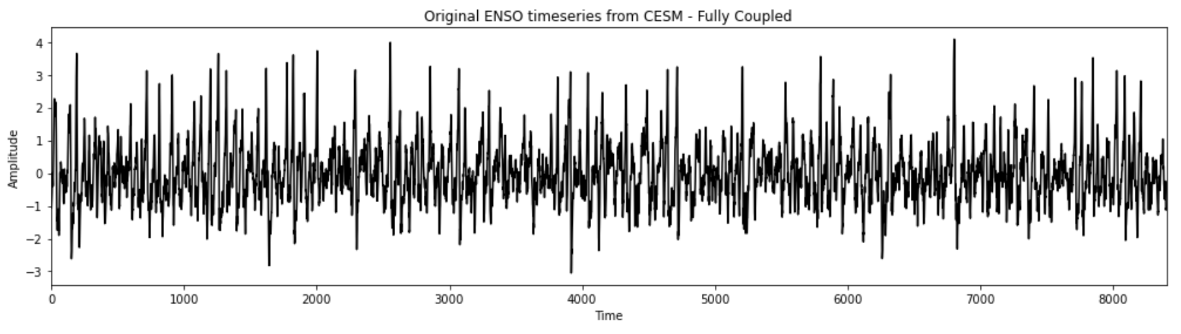

2) Calculate the power spectrum of your original data. Calculate the power spectra of the Nino3.4 SST index (variable called “nino34”) in the fully coupled model 1850 control run. Apply the analysis to the first 700 years of the run. Use Welch’s method (WOSA!) with a Hanning window and a window length of 50 years. Make a plot of normalized spectral power vs. frequency. Where is there power that you might be able to remove with filtering?

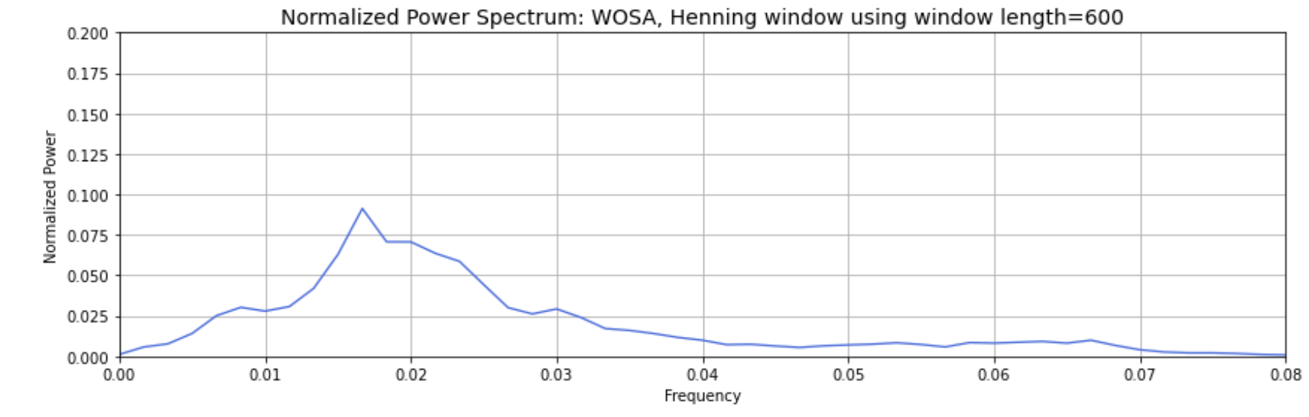

There is power up to .08/month that we could remove.

3) Apply a Butterworth Filter. Use a Butterworth filter to remove all spectral power at frequencies greater than 0.04 per month (i.e., less than 2 year). Use an order 1 Butterworth filter (N=1, 1 weight). Replot the original data and the filtered data. Calculate the power spectra of your filtered data. Assess the influence of your filtering in both in time domain (i.e., by comparing the original data time series and filtered time series data) and the frequency domain (i.e., by comparing the power spectrum of the original data and the power spectrum of the filtered data). Look at the response function of the filter in spectral domain using the convolution theorem. Well that was pretty boring… we still have most of the power retained….

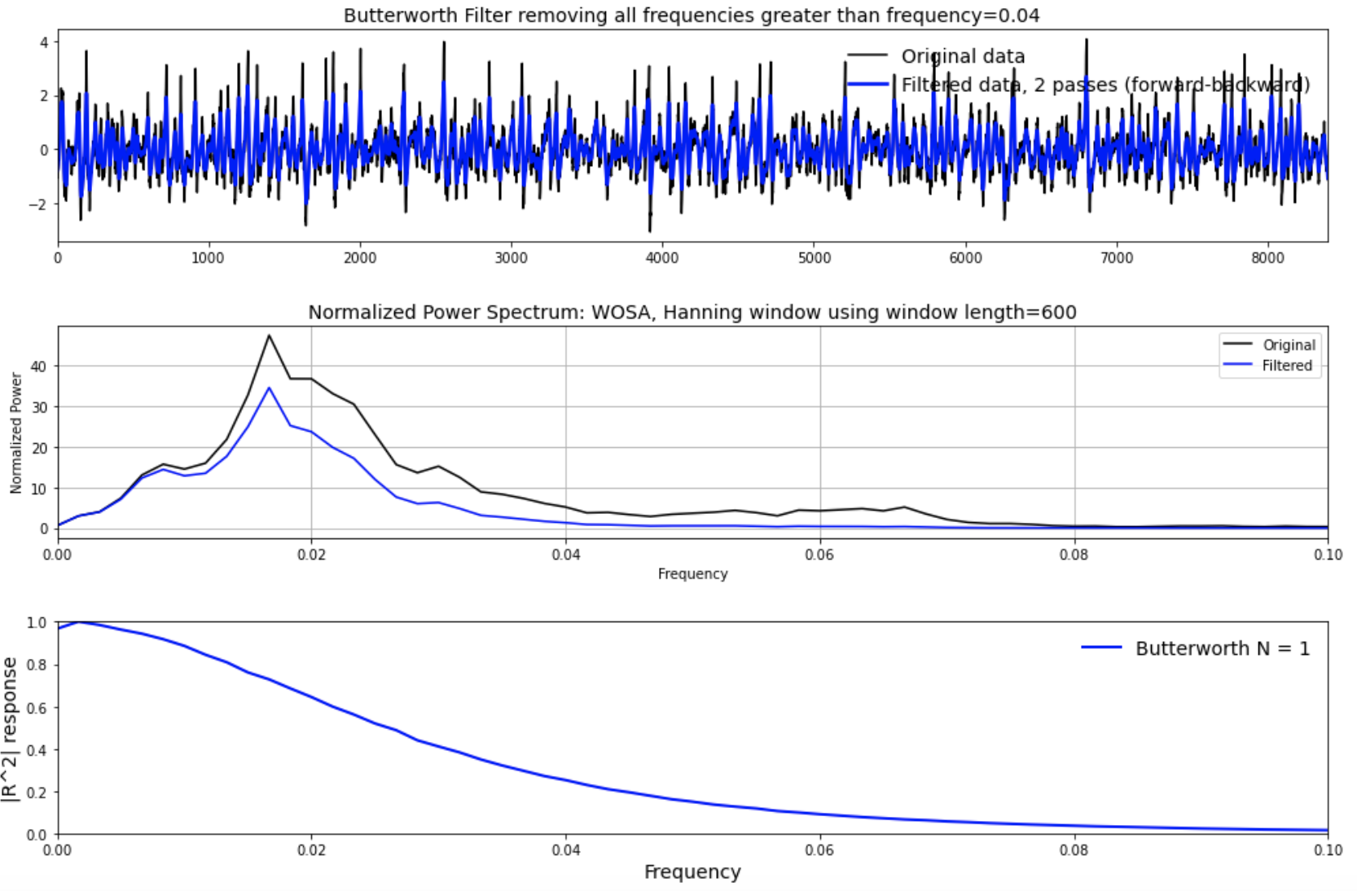

By using the Butterworth filter, the timeseries is slightly smoothed, but the overall trend is still visible. There is hardly any power past .04 in the filtered data. Most of the power was retained.

4) Let’s apply another Butterworth Filter and this time really get rid of ENSO power!. Let’s really have some fun with the Butterworth filter and have a big impact on our data... Let’s remove ENSO variability from our original timeseries. Apply the Butterworth filter but this time change the frequency that you are cutting off to 0.01 per month (i.e., remove all power with timescales less than 8 years). Use an order 1 filter (N=1). Replot the original data and the filtered data. Calculate the power spectra of your filtered data. Assess the influence of your filtering in both in time domain (i.e., by comparing the original data time series and filtered time series data) and the frequency domain (i.e., by comparing the power spectrum of the original data and the power spectrum of the filtered data). Look at the response function of the filter in spectral domain using the convolution theorem.

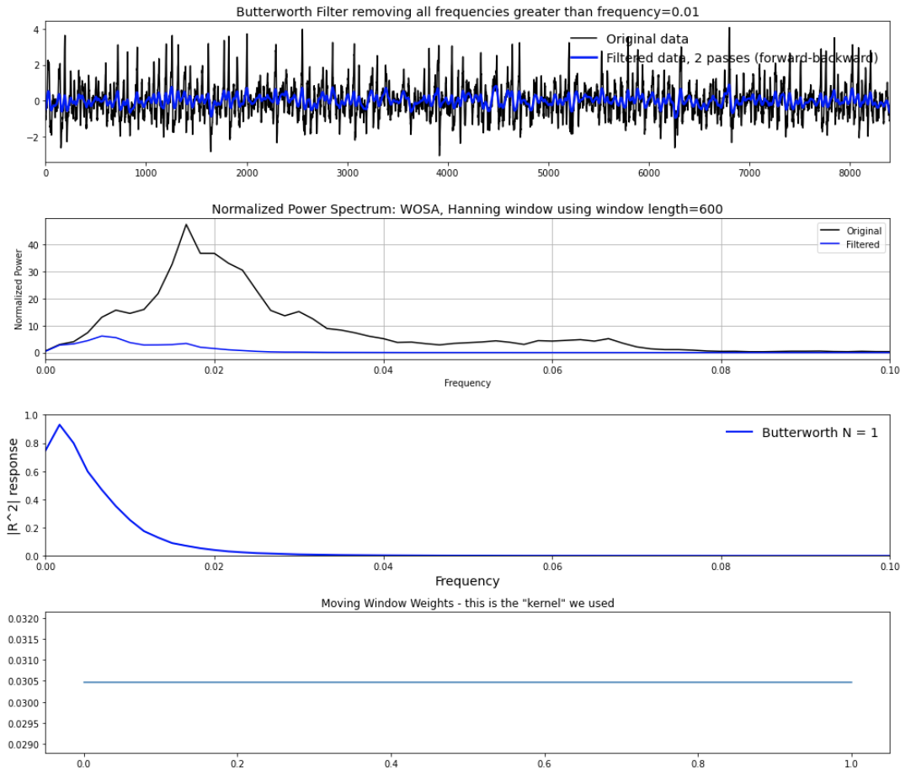

5) Let’s apply yet another Butterworth Filter – and this time one with more weights. Repeat step 4) but this time change the order of the filter. In other words, increase the number of weights being used in the filter by increasing the parameter N in the jupyter notebook. What is the impact of increasing N on the filtered dataset, the power spectra, and the moving window weights? You should see that as you increase N – a sharper cutoff in frequency space occurs in the power spectra. Why?

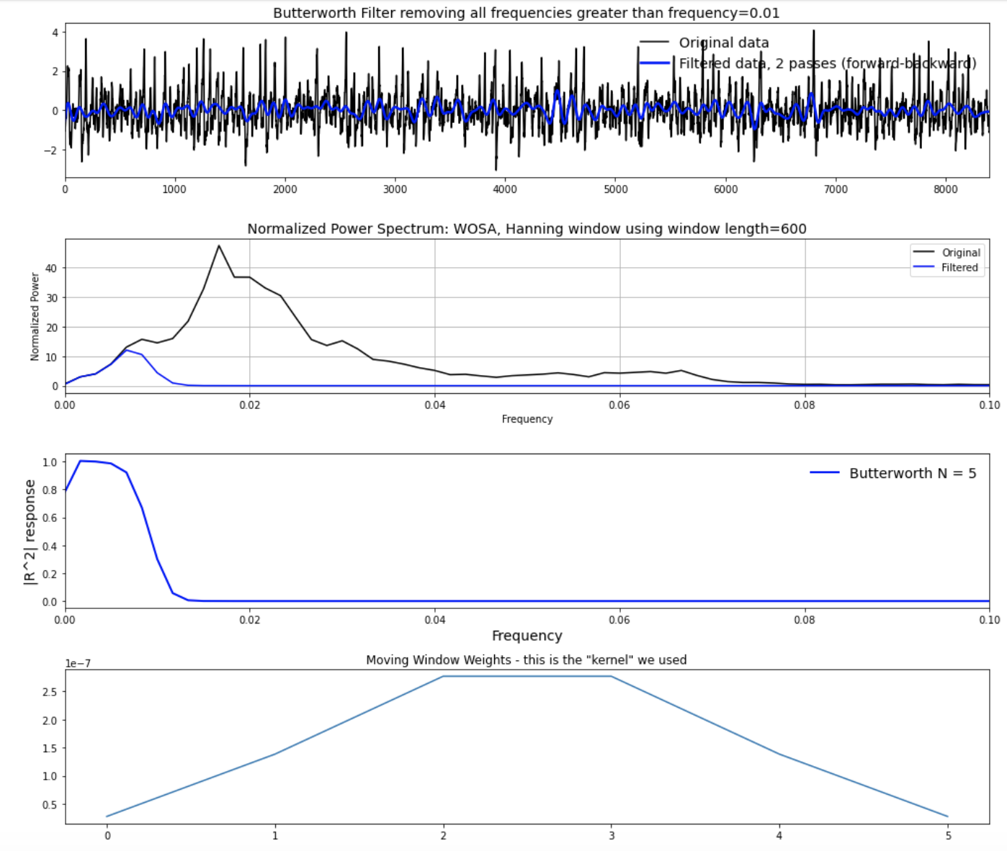

The sharper cutoff occurs when N is increased because the response function becomes much steeper. N is a key part of the response function in the response function formula:

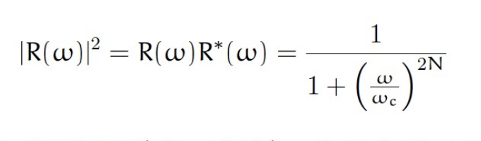

As we can see from the formula, as N increases, the response function quickly approaches zero.

6) Assess what is “under the hood” of the python function. How are the edge effects treated? Why is the function filtfilt filtering twice?

The formulas used in the calculation are under the hood. Edge effects are treated with the padding method with the specified symmetry. The function filters twice because it can filter edges from both directions at least once.